Bourdon Tube Pressure Gauges MAN-R, MAN-Q
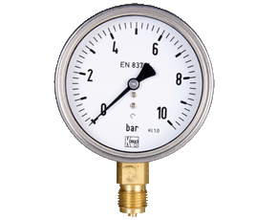 |  | 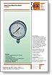  Download PDF datasheet | Measuring range: -1 up to 0 ... 0 up to 1000 bar  Connection: G 1/4, G ½ AG, brass  Housing Material: st. st., plastic  Diameter of housing: 63, 80, 100, 160 mm  Accuracy class: 1,6 or 1,0  Option: contacts, glycerine filling
All Stainless Steel Bourdon Tube Pressure Gauges MAN-R
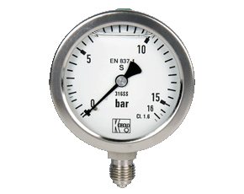 |  | Download PDF datasheet | Measuring range: -1 up to 0 ... 0 up to 1000 bar  Connection: G 1/4, G ½ male, st. st.  Housing Material: st. st.  Diameter of housing: 63, 100, 160 mm  Accuracy class: 1,6 or 1,0  Option: contacts, glycerine filling
All Stainless Steel Bourdon Tube Pressure Gauges for Exceptional Safety MAN-R...S
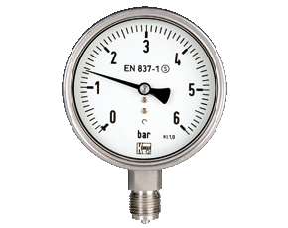 |  | Download PDF datasheet | Measuring range: -1 up to 0 ... 0 up to 1000 bar  Connection: G 1/4, G ½ male, st. st.  Housing Material: st. st.  Diameter of housing: 63, 100, 160 mm  Accuracy class: 1,6 or 1,0  Option: contacts, glycerine filling
Bourdon tube pressure gauges for refrigerants MAN-T
Pressure Gauge Digital with Ceramic Sensor Element MAN-LD
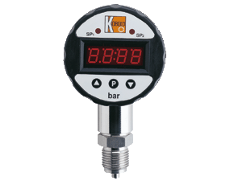 | 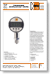  Download PDF datasheet | Measuring range: -1 up to 0 ... 0 up to 1600 bar  Connection: G ¼, G ½ male, ¼ NPT, ½ NPT st. st.  Housing Material: glasfibre reinforced plastic  Diameter of housing: 74 mm  Accuracy class: 0,5  Power supply: 24 VDC ± 20%  Option: contact, analogue output, peak memory
Differential Pressure Gauge with Diaphragm MAN-Dx2A
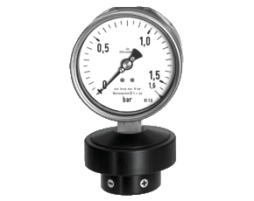 | 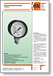  Download PDF datasheet | Measuring range: 0 up to 25 mbar ... 0 up to 25 bar  Connection: G ¼ female, aluminium  Housing Material: st. st.  Diameter of housing: 100, 160 mm  Accuracy class: 1,6  Option: glycerine filling
 |  | 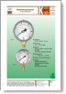  Download PDF datasheet | Skale: pressure and 1..3x temperature  Measuring range: -1 up to +9....-1 up to +40 bar  Connection: G 1/4st. Steel, 7/16 UNF brass  Housing Material: steell, st. St.  Diameter of housing: 63, 80, 100 mm  Accuracy class: 1,6 or 1,0  Option: contacts, glycerine filling
  Differential Pressure Gauge with Bourdon Tube MAN-DG12R
  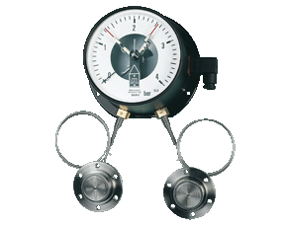 | Download PDF datasheet | Measuring range: 0 up to 1 bar ... 0 up to 60 bar  Connection: G ½ AG, brass  Housing Material: steel, aluminium  Diameter of housing: 160 mm  Accuracy class: 1,6  Option: glycerine filling
Capsule Element Pressure Gauges MAN-K
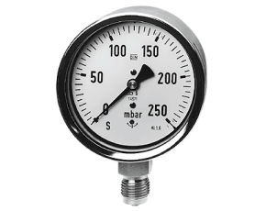 |  | 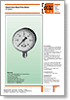  Download PDF datasheet | Measuring range: -25 up to 0 mbar ... -600 up to 0 mbar  0 up to 25 mbar ... 0 up to 600 mbar  Connection: G 1/4, G ½ AG, brass  Housing Material: st. st.  Diameter of housing: 63, 80, 100, 160 mm  Accuracy class: 1,6
Diaphragm Pressure Gauges MAN-P
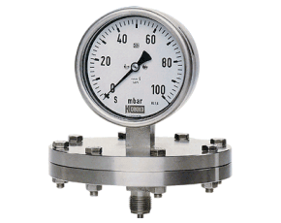 |  | 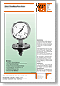  Download PDF datasheet | Measuring range: -16...0 up to 0...250 mbar, -1...0 up to 0..40 bar  Connection: G ½ male, steel, st. st.  Housing Material: st. st.  Diameter of housing: 100, 160 mm  Accuracy class: 1,6; 2 ,5  Option: contacts, glycerine filling
Differential Pressure Sensor PMP
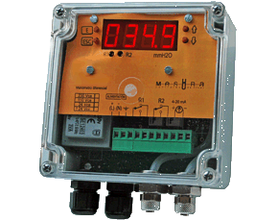 | 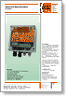  Download PDF datasheet | For air or neutral gases (e.g. monitorng of filters)  Measuring range: 0 up to 500 Wc (0..50 mbar)  Connection: hose connector 6x8 mm  Indication: 4-digit LED  Analogue output 4-20 mA, 2 relay (max. 230 Vac, 0,5 A)  Power supply: 24, 110, 230 VAC, 24 VDC
Differential Pressure Gauge PAD
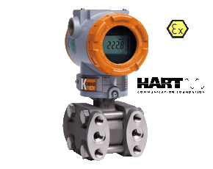 | 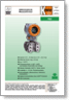  Download PDF datasheet | Measuring range: 0...41370 kPa  Connection: ¼ NPT, ½ NPT  Housing Material: st. st.  Accuracy: ±0,075% of meas. range
All Stainless Steel Pressure Gauge with All Stainless Steel Pressure Gauge with In-Line Diaphragm Diaphragm MAN-RF..M1..DRM-628
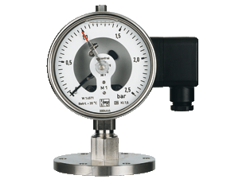 | Download PDF datasheet | with diaphragm seal  Measuring range: 0 up to 1 ... 0 up to 40 bar  Connection: flange DN25 - DN 100, st.st.  Diaphragm: 24 up to 64 mm, st. steel  Housing Material: st. st., aluminium  Diameter of housing: 100 mm  Accuracy class: 1,6  Option: contacts, glycerine filling,  remote version, vibration damping
Pressure Switch with Ceramic Element/Thin Film PSC
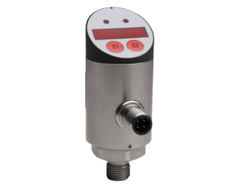 | 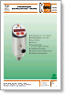  Download PDF datasheet | Switching range: -1 up to +2 bar ... 0 up to 700 bar  Connection: G 1/4, G 1/2, ¼ NPT, ½ NPT  Housing: st. st.  Max. temperature:80 °C (media)  2 Semiconductor PNP/NPN or  1 Semiconductor PNP/NPN and analogue output  digital display, programmable
Pressure Sensor with Diaphragm Seal and AUF SEN..DRM-600
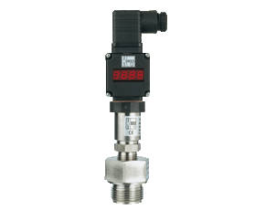 | 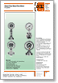  Download PDF datasheet | with diaphragm seal  Measuring range: 0 up to 6 ... 0 up to 600 bar  Connection: G ½ - 1 ½, ½ - 1 ¼ NPT, M20x1,5, M48x3  Diaphragm: 18 up to 40 mm, st. steel  Housing Material: st. st.  Accuracy class: 1,0  Analogue output, digital indicator  Option: remote version, vibration damping
Pressure Transmitter PAS
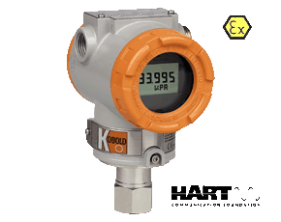 | Download PDF datasheet | Measuring range: -1 up to 0 bar ... 0 up to 400 bar  Connection: G 1/4, G 1/2, ¼ NPT, ½ NPT  Housing: st. st.  Max. temperature:80 °C (media)  analogue output 0(4)-20 mA, digital display
Pressure Switch with st. st. Sensor System SCH-DNS
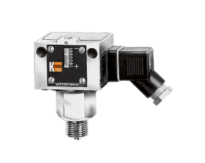 | 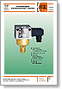  Download PDF datasheet | Switching range: -250 up to 100 mbar ... 3 up to 16 bar  Connection: R 1/2 male and 1/4 female  Housing: aluminum (sea-water resistant)  Max. temperature:85 °C (media)  Micro switch
Vacuum Switch SCH-VCM
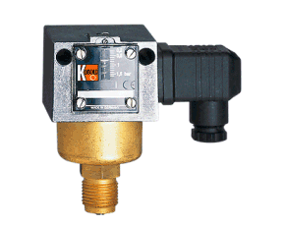 | Download PDF datasheet | Switching range: -15 -up to +6 mbar ... -1 up to +0,1 bar  Connection: R 1/2 male and 1/4 female  Housing: brass, st. st.  Max. temperature:85 °C (media)  Micro switch, option: proximity switch
Press./Diff. Press. Switch for neutr. gases SCH-HCD, SCH-DPS
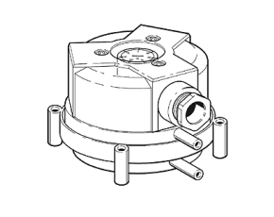 | 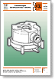  Download PDF datasheet | Switching range: 0,2 up to 3 mbar ... 15 up to 150 mbar  40 up to 400 mPas...500 up to 2500 mPas  Connection: G 1/8, G ¼ female, stub 6 mm  Housing: PA/POM, aluminum  Max. temperature: 60 (85) °C (media)  Micro switch

