Temperature Switch TWR
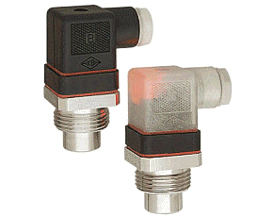 | 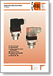  Download PDF datasheet | Switch points: +30 ... +120 (in 5 or 10 °C steps)  fixed  Connection:G ¾ male, brass or st. st.  Electrical connection: plug DIN 43 650  Switching Accuracy: 30..+90 °C ± 5 °C  100-120 °C ± 7 °C  Hysteris: max. 20 °C
Thermal Reed Switches TRS
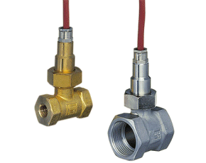 | 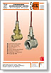  Download PDF datasheet | Switch points: +10 ... +120 (in 5 bzw. 10 °C Schritten)  fixed  Connection:G ¼...G 1 male, brass or st. st.  Electrical connection: cable  Switching Accuracy: ± 3 °C  Hysteresis: < 7 °C
Temperature Switch-Digital TDD-1,-3,-5,-7
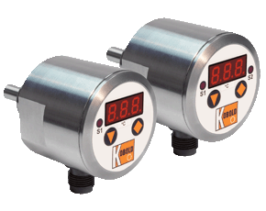 | 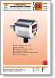  Download PDF datasheet | Switch points: -20 ... +125 °C, adjustable  Connection:G ½, G¾ male, ½, ¾ NPT st. st.  Indication: 3-digit LED  Electrical connection: plug M12x1 or cable  Supply: 24 VDC  Contact: 1 or 2 semiconductors PNP/NPN  N/O or N/C adjustable  Switching Accuracy: ±0, 5 °C (-10...+85 °C)
Temperature Switch-Digital TDD-D6
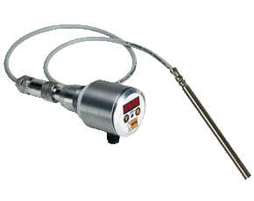 | Download PDF datasheet | Switch points: -20 ... +125 °C, adjustable  Connection:G 1/2, G3/4 male, 1/2, ¾ NPT st. st.  Indication: 3-digit LED  Electrical connection: plug M12x1 or cable  Supply: 24 VDC  Contact: 1 or 2 semiconductors PNP/NPN  N/O or N/C adjustable  Switching Accuracy: -10...+85 °C, ±0, 5 °C
Glass Thermometer for Machines TGL
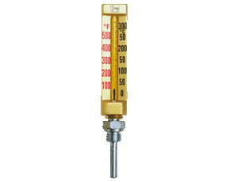 | 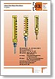  Download PDF datasheet | Measuring range: -60 ... +40 up to 0 ... 200 °C  Connection: G ½ or ½ NPT, brass  Housing Material: aluminum  Housing length: 110, 150 or 200 mm  Accuracy class: 1,0
Capillary Thermometer according to DIN 16205 TNF
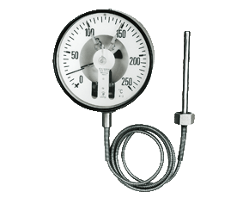 | 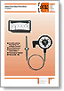  Download PDF datasheet | Measuring range: -20 ... +40 up to 0 ... 600 °C  Connection: back or bottom  G ½... G1, ½ NPT...1 NPT, TriClamp, and so on  Housing Material: aluminum, st. st., plastic, steel  Diameter of housing: 63, 80, 100,160 or 250 mm  Accuracy class: 1,0 or 1,6  Option: contacts, gliding pointer, oil filling, and so on
Safety Thermometers with Contact TNS, TNF
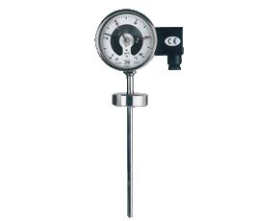 | 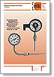  Download PDF datasheet | Measuring range: -20 ... +40 up to 0 ... 600 °C  Connection: back or bottom  G ½... G1, ½ NPT...1 NPT, TriClamp,  and so on  Housing Material: aluminum, st. st., plastic, steel  Diameter of housing: 63, 80, 100,160 or 250 mm  Accuracy class: 1,0 or 1,6  Option: contacts, gliding pointer, oil filling
Stem Thermometer for Diesel Engines TND
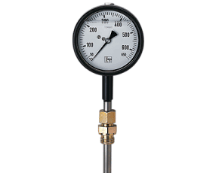 | 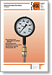  Download PDF datasheet | Measuring range: 0 ... +600 up to 0 ... 800 °C  Connection: bottom, G ½, G ¾  Housing Material: steel or st. st. with silicone filling  Diameter of housing: 63, 80, 100 mm  Accuracy class: 1,6 (63, 80 mm), 1,0 (100 mm)  Option: damping spring
Temperature sensor TDA
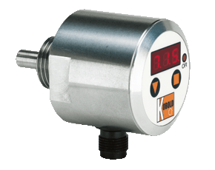 | Download PDF datasheet | Measuring range: -50 ... +125 °C  Connection:G 1/2, G3/4 male, 1/2, ¾ NPT st. st.  Material: st.st.  Indication: 3-digit LED  Electrical connection: plug M12x1 or cable  Supply: 24 VDC  analogue output 0(4)-20 mA, programmable,  Semiconductor PNP/NPN, digital display  Accuracy: ±0, 5 °C (for range -10...+85 °C)
Infrared Hand-Held Thermometer TIR-HN
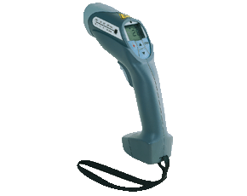 | 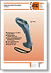  Download PDF datasheet | Non- contact temperature measurement  Measuring range: -20 ... +500 up to -32 ... 900 °C  Measuring Accuracy: ± 1 % up to ±2 % of m. value  Option: analogue output, RS 232, data memory,  Laser pointer, statistical functions
Precision Hand-Held Thermometer HND-T120
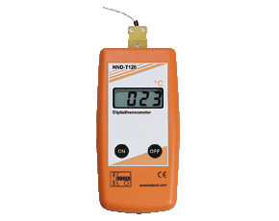 | 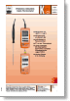  Download PDF datasheet | Measuring range: -50 ... +1150 °C  Probe: Thermo couples K  Accuracy: 1 %  Supply: 9 V battery
Precision Hand-Held Thermometer HND-T115,-T215
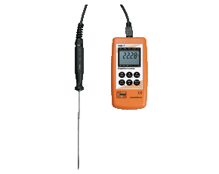 | Download PDF datasheet | Measuring range: -220 ... +1370 °C, -50..+1750°C  Probe: Thermo couples  Accuracy: ± 0,03 % of m. value  Supply: 9 V battery  Holding Function, min/max. -memory, °C/°F  data logger, RS 232
Room Thermometers TWL-ST
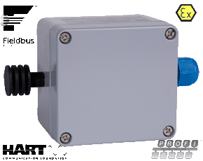 |  | Measuring range: -20...+60 °C  Connection: wall mounting  Sensor: Pt 100, class A or B, 4-20 mA
Search product types
Pipe Temperature Sensor for Reliable Dead-Zone-Free TWP
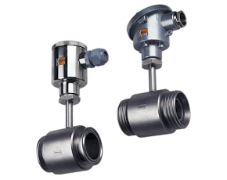 | 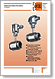  Download PDF datasheet | Measuring range:-20 ... +200 °C  Connection: Hygenic connection, Triclamp  Pipe: st. st. DN 15..DN 80  Sensor: Pt100  Head B or field housing
Thermocouples (according to DIN) TTD
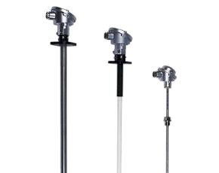 | 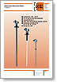  Download PDF datasheet | Predection tube Form AM, AK, B, BM, MA  Measuring range: -200.. +600 up to -200... 1150 (1200) °C  Connection: G ½, sliding flange  Material of predective tubes: steel, st. st., ceramics  Sensor: FeCu-Ni, NiCr-Ni, class 2  Option: head mounted transmitter 4-20 mA

